**TABLE OF CONTENTS**

|  |  |  |
| --- | --- | --- |
| **Serial**  **No.** | **TITLE** | **PAGE NO.** |
| 1 | **User Interface Design** | 2 |
| 1.1 | Login page | 2 |
| 1.2 | Register page | 2 |
| 2 | Home page | 3 |
| 2.1 | Display of Services | 3 |
| 2.2 | Display of featured product | 4 |
| 3 | Display of All images | 5 |
| 4 | Display of Traditional arts | 6 |
| 5 | Display of modern arts | 6 |
| 6 | Display of non-profit arts | 7 |
| 7 | Display of rental arts | 7 |
| 8 | Upload image page | 8 |
| 9 | Membership | 8 |
| 10 | Add to cart | 10 |
| 11 | Payment page | 11 |

**USER INTERFACE DESIGN**

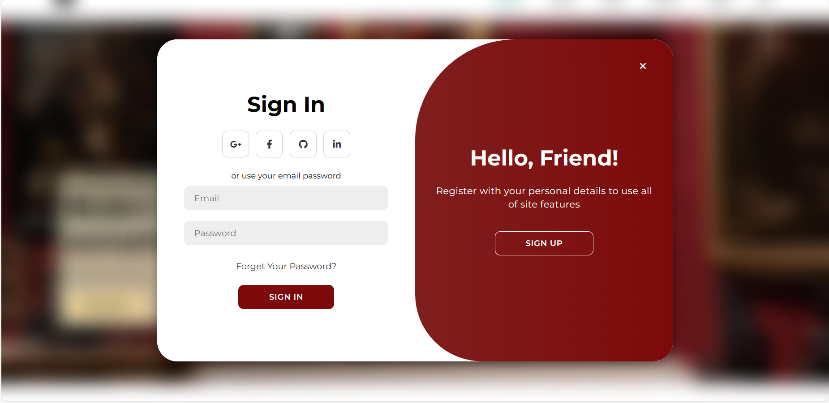

1.1 Login page

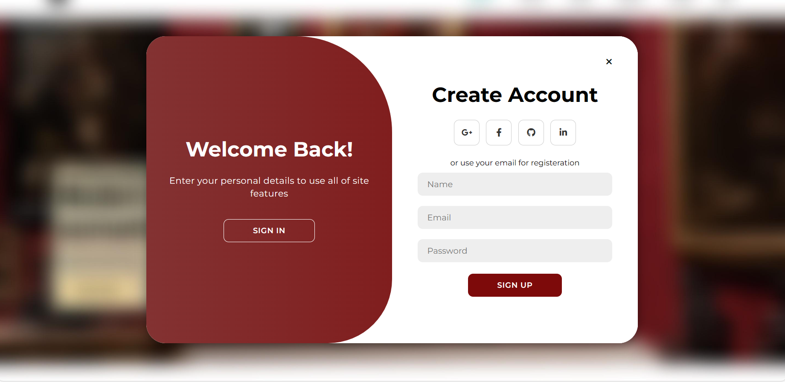

1.2 Register page

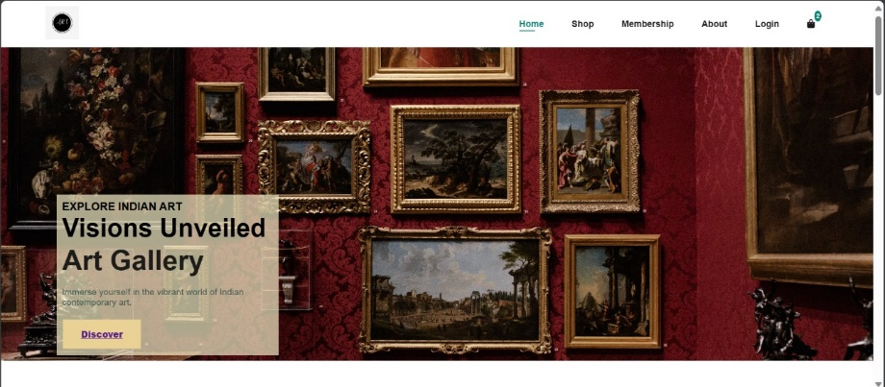

2. Home page

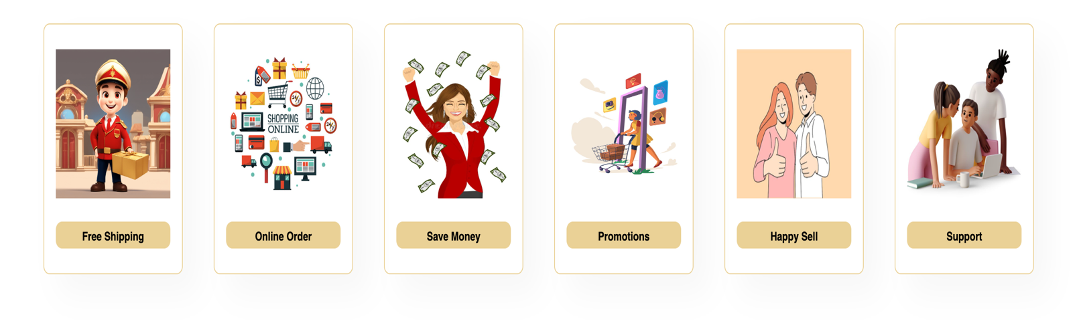

2.1 Services

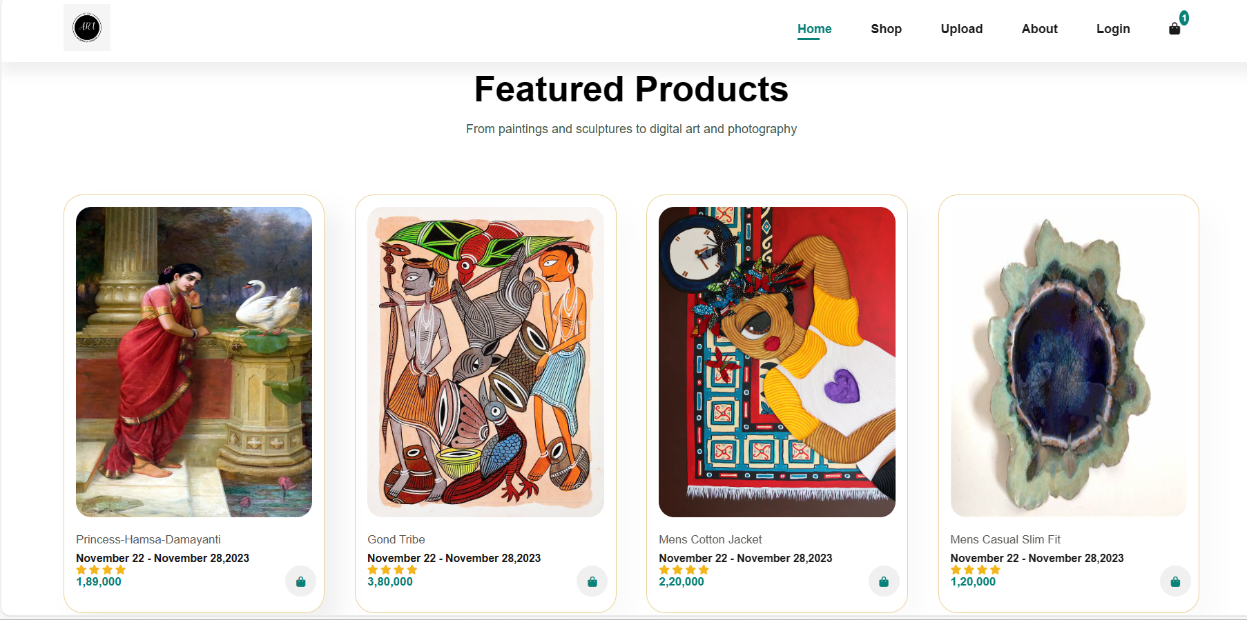

2.2 Display of Featured products

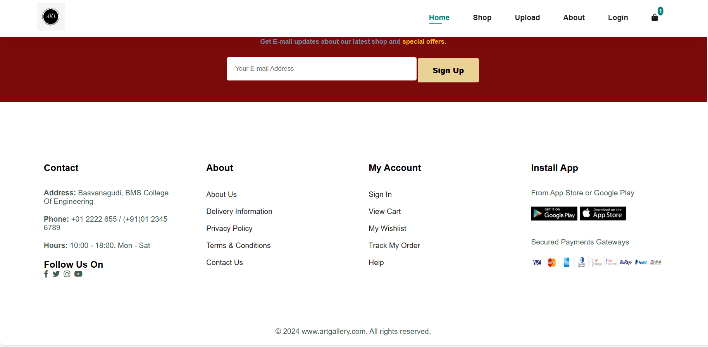

2.2(a) Display of Footer

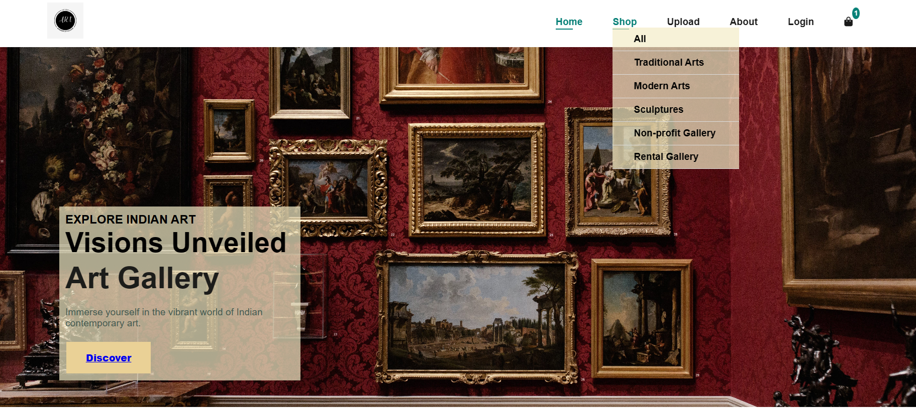

2.2(b) Drop down menu of shop.

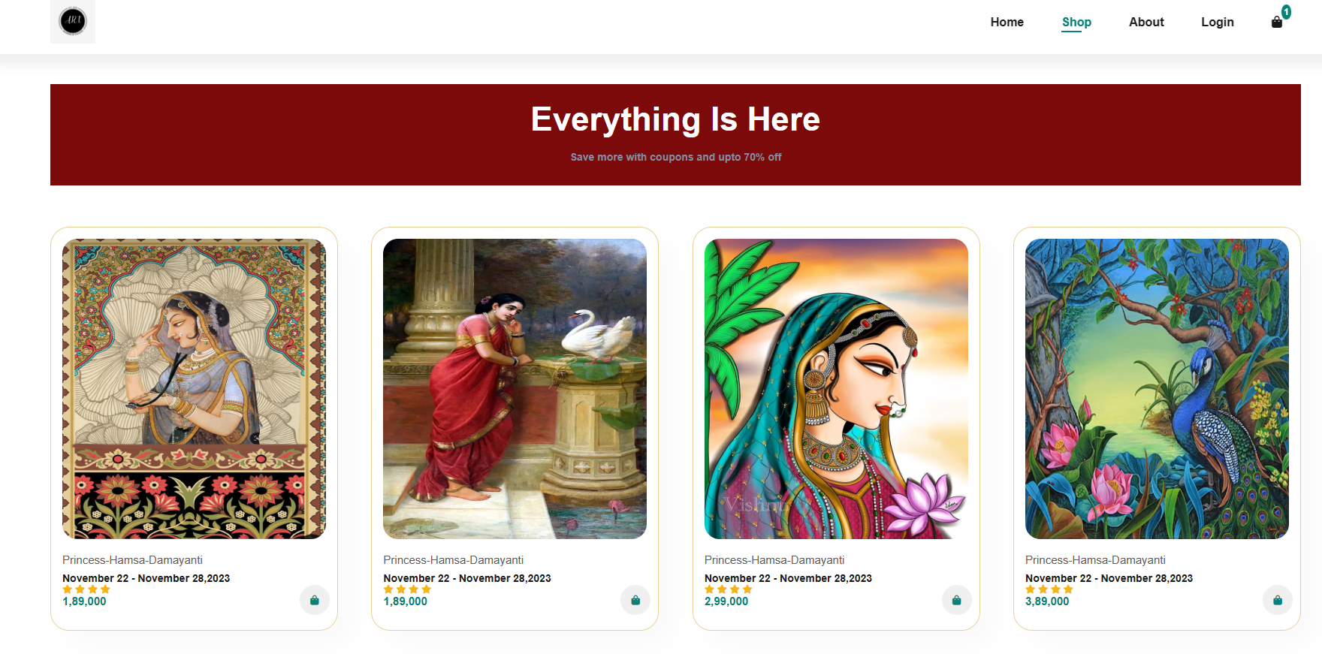

3. Display of ALL page under shop

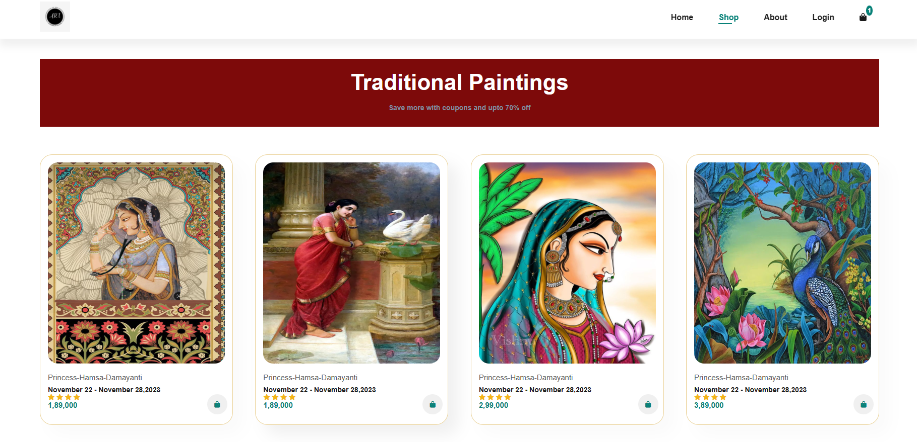

4. Display of Traditional arts page under shop

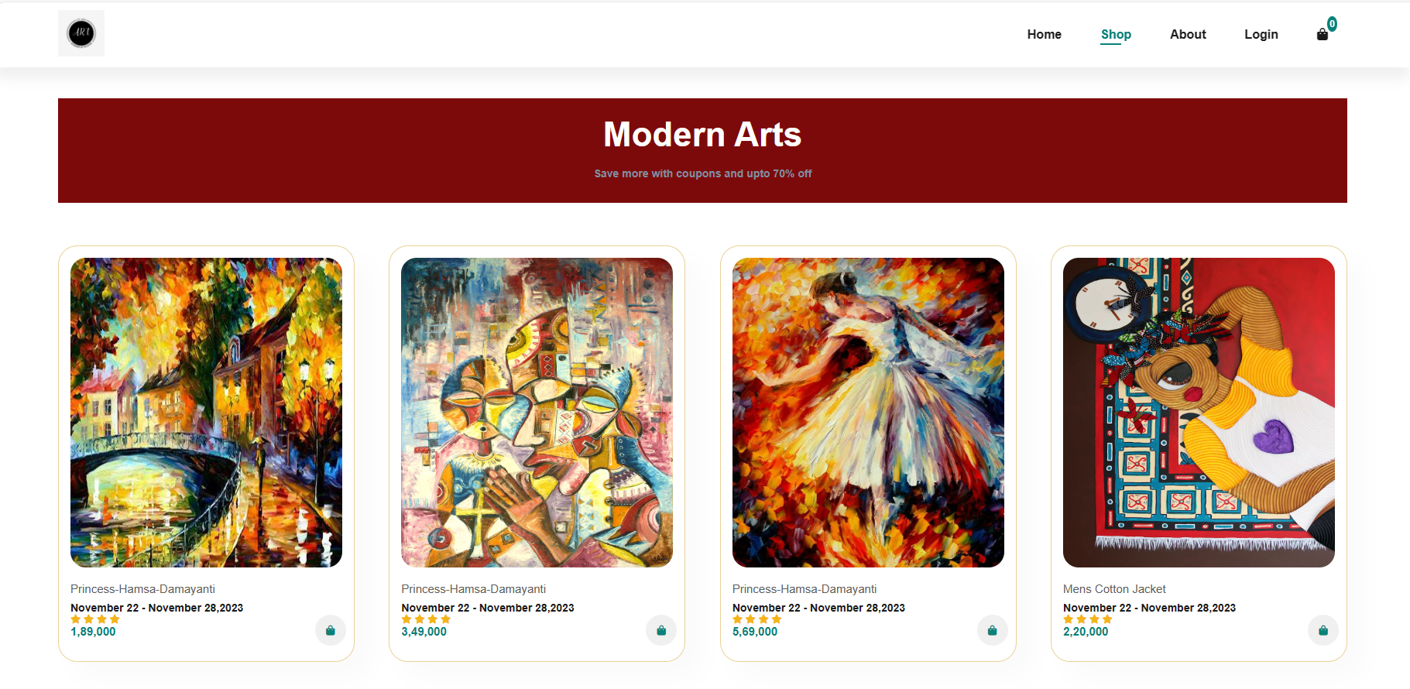

5. Display of modern arts page under shop

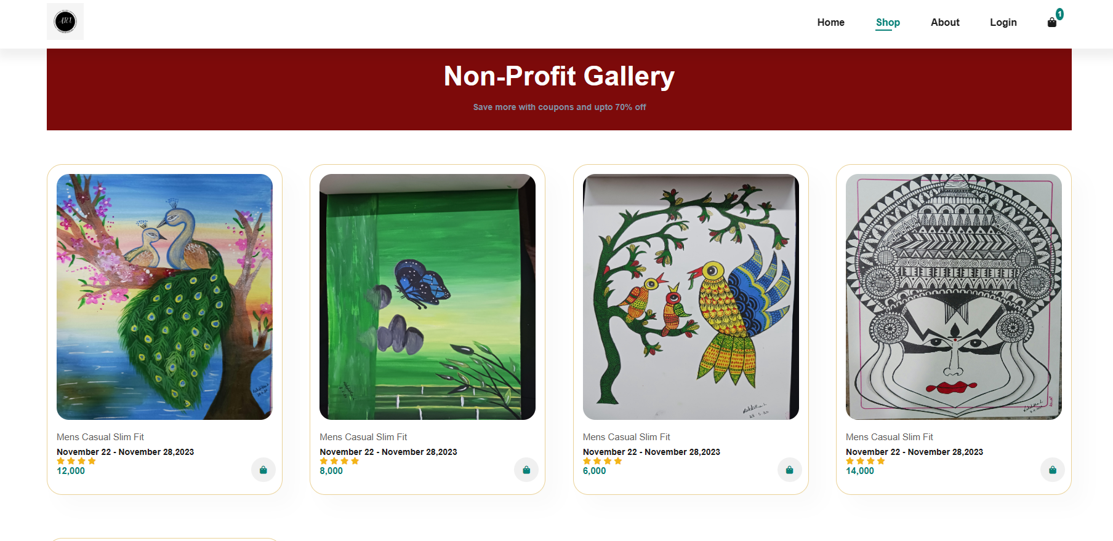

6. Display of Non-profit gallery page under shop

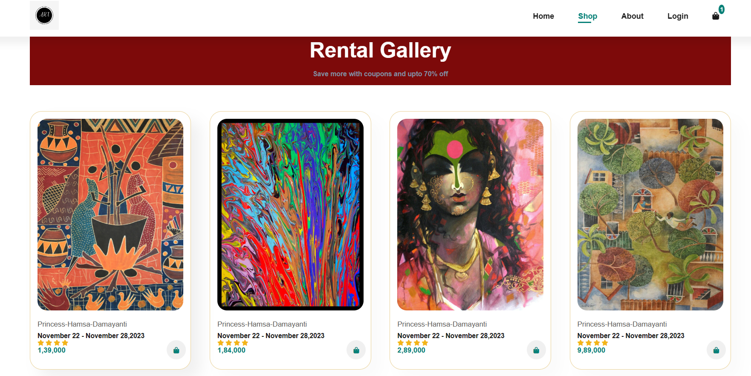

7. Display of rental arts page under shop

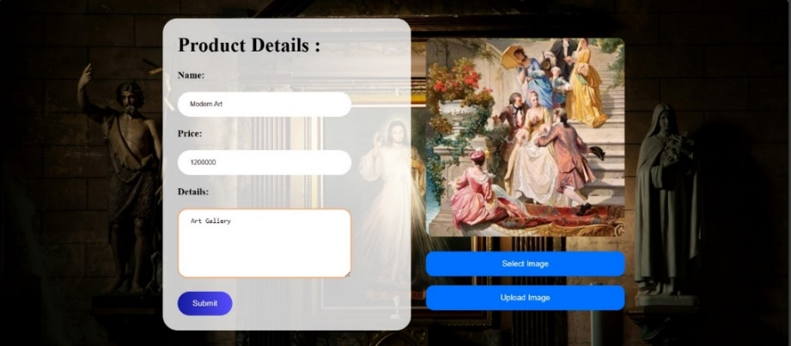

8. Display of upload image page with product details

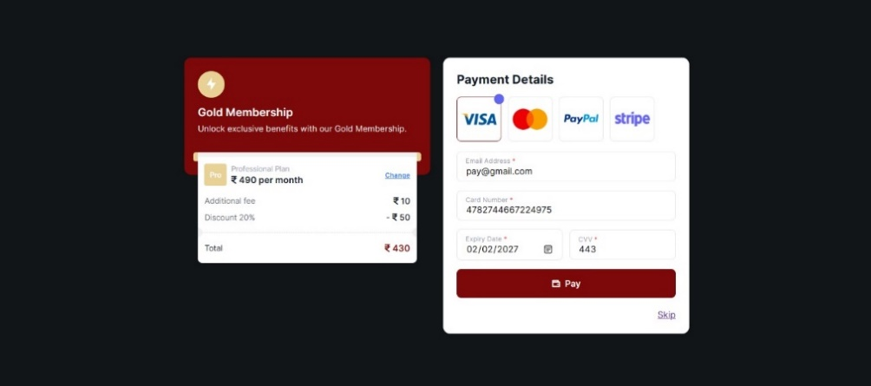

9. Display of registering for membership page

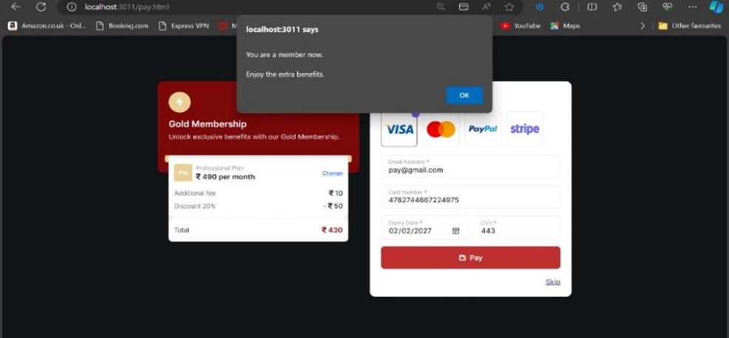

9.1(a) Display of pop window with a message

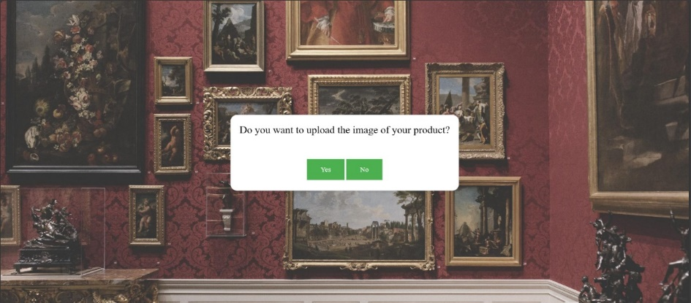

9.1(b) Display of upload image page

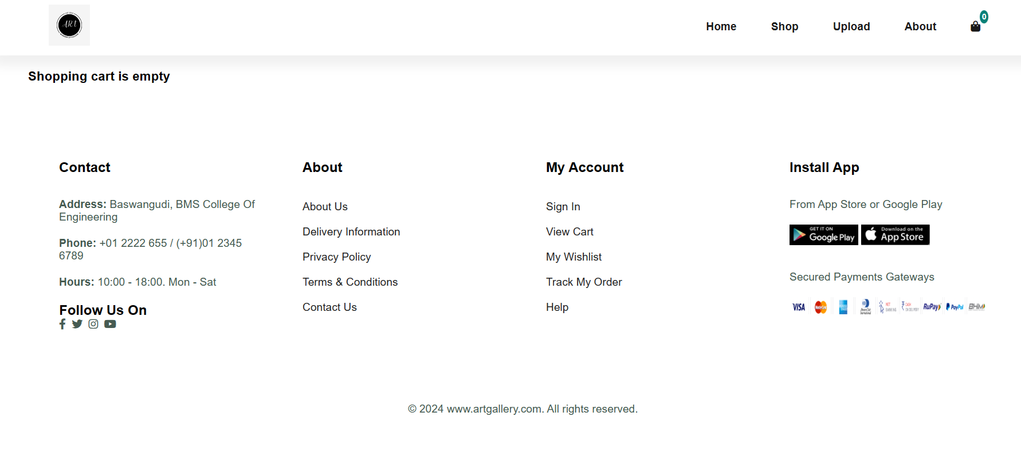

10. (a) Display showing shopping cart is empty

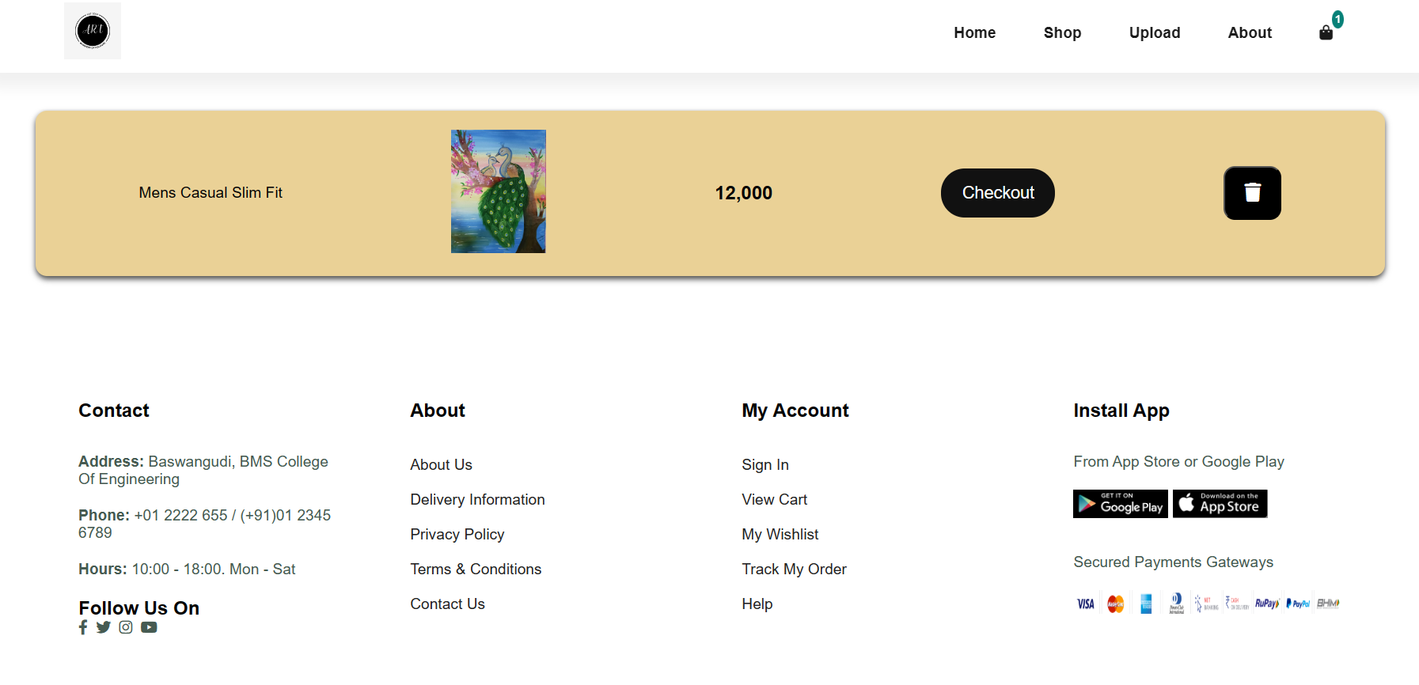

10. (b) Display of Add To Cart page

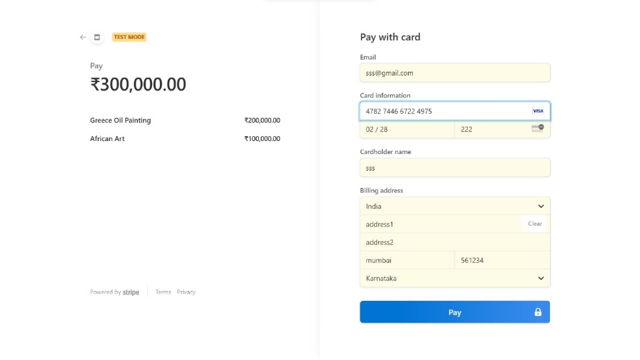

11. Payment page